The physical properties of water
P. Ballo, peter.ballo@stuba.sk, Department of Physics, Faculty of Electrical Engineering and Information Technology, Slovak University of Technology, Ilkovicova 3, 812 19 Bratislava, Slovak Republic

Introduction

Water (H₂O) is a miracle liquid. It is essential for all living organisms (on our planet at least), and it is often referred to as a universal solvent because many substances dissolve in it. Water exists primarily as a liquid at room conditions, but a significant amount can often be found in the atmosphere. At room temperature, it is a nearly colorless (in small quantities), tasteless, and odorless liquid. Its density is great enough to support the bodies of many types of creatures, often eliminating or reducing the need for elaborate skeletons. The surface tension of water helps it climb trees and support small organisms. Saltwater oceans hold 97% of surface water composing of about 70% of the Earth's surface as liquid and solid state. In addition to being found in the atmosphere as a vapor. However, the availability of drinking water is inadequate. For this reason, water is a strategic resource in the globe and an important element in many political conflicts. Some have predicted that clean water will become the "next oil", making Canada (and maybe also Slovakia), with these resources in abundance, possibly the richest countries in the world.

The water molecule and water clustering
Water is a tiny V-shaped molecule comprised of two hydrogen atoms bonded to a single oxygen atom. Its molecular diameter is about 2.75 Å. The molecule is symmetric with two mirror planes of symmetry and a 2-fold rotation axis. In liquid water, the mean O-H length is about 0.097 nm, the mean H-O-H angle is about 106°. Individual water molecules will have different values dependent on their energy and surroundings.

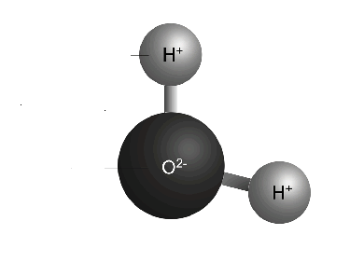

Fig.1. Structure of water molecule. Dark sphere represents oxygen and small medium-gray spheres represent hydrogen.
The oxygen of one water molecule has two lone pairs of electrons. As a gas is the molecule one of lightest known but as a liquid is much denser as expected. The miracle properties of water that are of interest are the result of its unique orbital configuration and the ways in which individual H₂O molecules interact with each other. The interaction is result of the fact that the bonding electrons are shared unequally by the hydrogen and oxygen atoms. In the liquid state in spite of 80% of the electrons is concerned with the atomic bonding. A partial negative charge (ð-) forms at the oxygen end of the water molecule, and a partial positive charge (ð+) forms at the hydrogen ends. The interaction between two water molecules forms a hydrogen bond (or hydrogen bridge). It should be noted that the first reported suggestion for clusters being responsible for water's anomalous density maximum at 3,984ºC was in 1884. Hydrogen bridge can repeat so that every water molecule is H-bonded with four other molecules (two through its two lone pairs, and two through its two hydrogen atoms.) Liquid water's high boiling point is due to the high number of hydrogen bonds each molecule can have relative to its low molecular mass. Note, the boiling point is over 150 K higher than expected by extrapolation of the boiling points of other hydrides. Small cluster of four water molecules may come together to form water bicyclo-octamers. The molecular arrangement (Fig. 2A) also occurs in high-density ice (ice-seven) whereas, with 60° relative twist, (Fig. 2B) is found in low density ice (hexagonal ice). Such equilibrium is balanced due to the existence of two minima in the potential energy (U) - molecular separation (r) diagram (Fig 3), which shows the approach of the water tetramers.

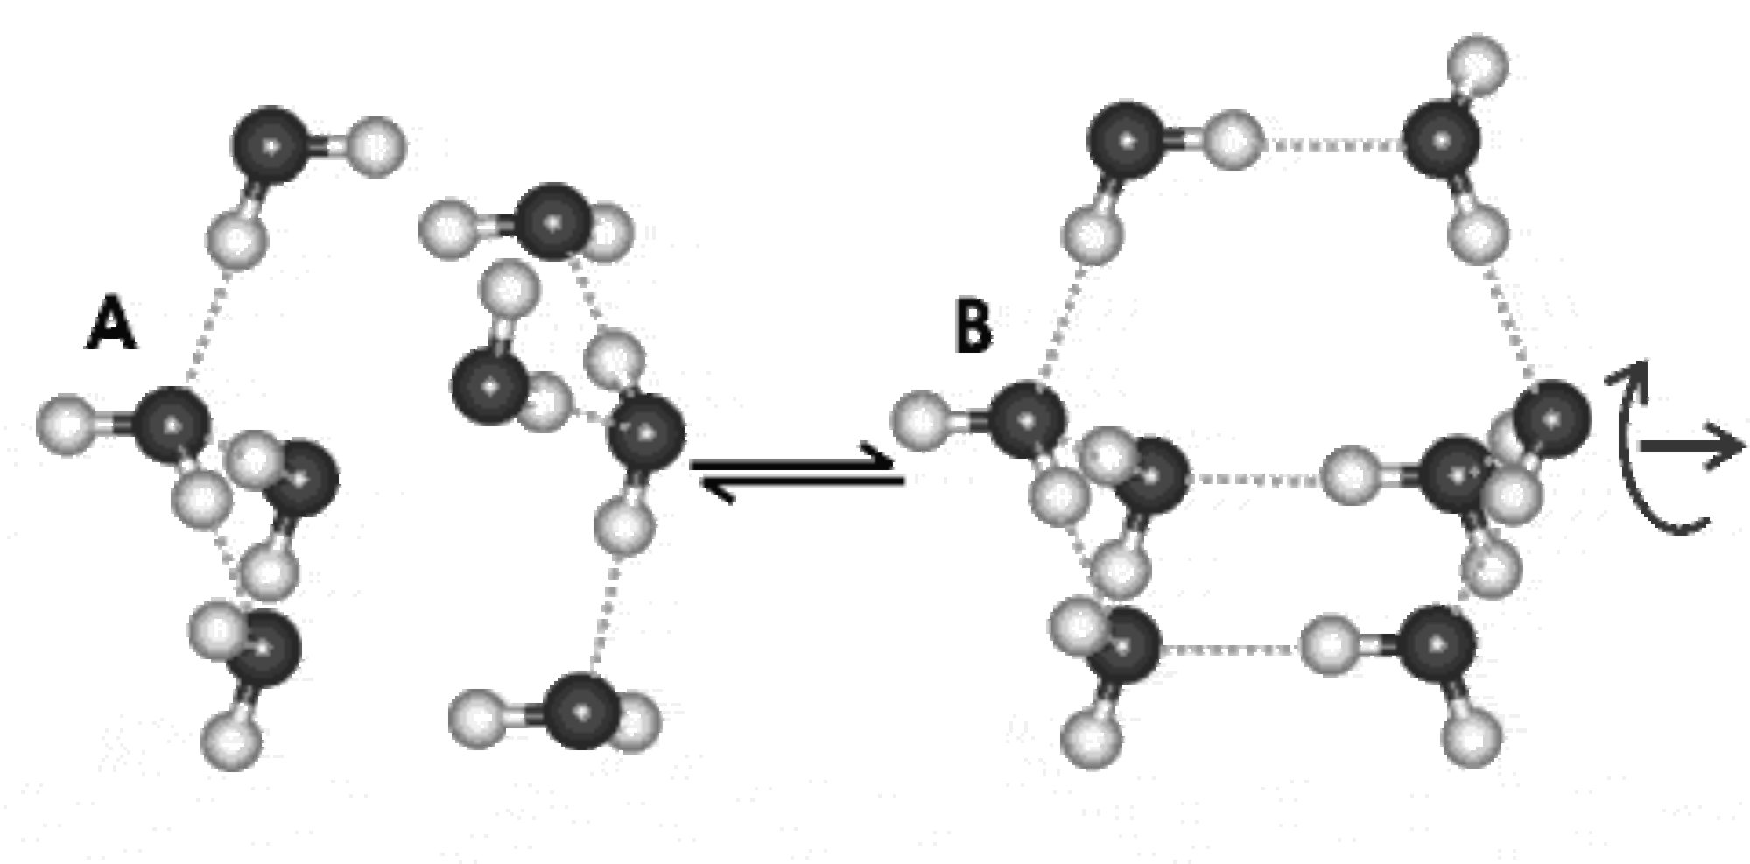

Fig. 2 Small cluster of four water molecules (left panel); The molecular arrangement (A) forms high-density ice-seven, the formation (B) is found in low density hexagonal ice. Dark spheres represent oxygen, white spheres represent hydrogen and dashed lines show hydrogen bonds.

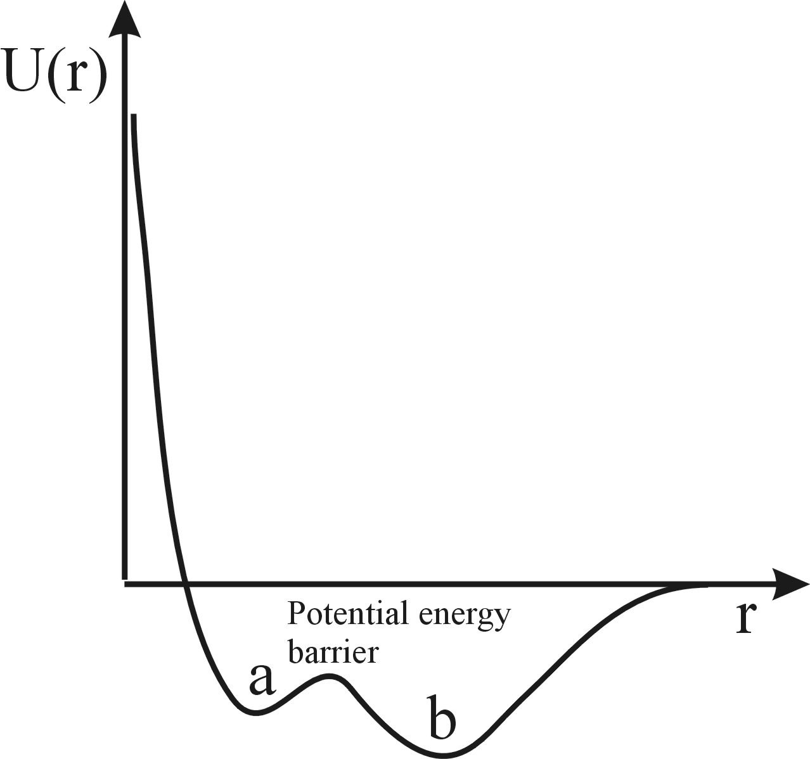

Fig. 3. The potential energy barrier between two states shown in Fig. 2 ensures that water molecules prefer either structure A or B with little time spent on intermediate structures.

Freezing water
Freezing water is an example of a phase transition -- a change in the physical properties of a substance when the temperature or pressure are changed. Phase transitions are often accompanied by either the absorption or release of thermal energy. The simple structure of the water molecule, H₂O, contrasts with the complex properties and phase diagram of stable/metastable, liquid/solid water. For example, ice exists in at least 15 different phases, including two phases, high density ice seven and low density hexagonal ice, both we mentioned before. Freezing transitions of liquid water involve a reduction in their spatial symmetry - ice is actually less symmetrical than liquid water - and increase in how orderly the molecules are arranged. Liquid water with a temperature close to the freezing point is actually more dense than ice, due to the fact that the crystalline arrangement of water molecules in ice is not the closest packing possible because of the shape of the molecules. The practical result of this fact is that ice floats. Furthermore, the freezing of water releases large amounts of heat. This means that water is very temperature stable at the freezing point. Winter weather is moderated to a great extent by this factor. Winter temperatures will stay near 0o C until all the local water is frozen.
A challenging form of water is metastable amorphous ice (also called glassy water). While water and its anomalous behaviour have been studied for more than 300 years the study of glassy water is relatively new: low-density amorphous (LDA) ice with density of 0.94 ± 0.02 g cm⁻³ was discovered 70 years ago, and high-density amorphous (HDA) with density of 1.17 ± 0.02 g cm⁻³ was obtained ∼20 years ago. The discovery of HDA demonstrated that water could have more than one amorphous solid state (polyamorphism). Five years ago, experimental results suggesting the existence of a third amorphous state, very high-density amorphous ice (VHDA) with density of 1.25 ± 0.01 g cm⁻³ , The discovery opened the possibility that more than two amorphous states could also be observed in other substances.

Can hot water freeze faster than cold water - The Mpemba effect
First we should point that hot water can in fact freeze faster than cold water for a wide range of experimental conditions and it can be seen and studied in numerous experiments. While this phenomenon has been known for centuries, and was described by Aristotle, Bacon, and Descartes, modern scientific community rediscovered the effect in 1963 (published in 1969), by a Tanzanian high school student named Mpemba. Because, no doubt, most readers are extremely skeptical at this point, we should begin by stating precisely what we mean by the Mpemba effect. We start with two containers of water, which are identical in shape, and which hold identical amounts of water. The only difference between the two is that the water in one is at a higher (uniform) temperature than the water in the other. Now we cool both containers, using the exact same cooling process for each container. Under some conditions the initially warmer water will freeze first. If this occurs, we have seen the Mpemba effect. It should be note, that the initially warmer water will not freeze before the initially cooler water for all initial conditions. If the hot water starts at 99.9° C, and the cold water at 0.01° C, then clearly under those circumstances, the initially cooler water will freeze first.

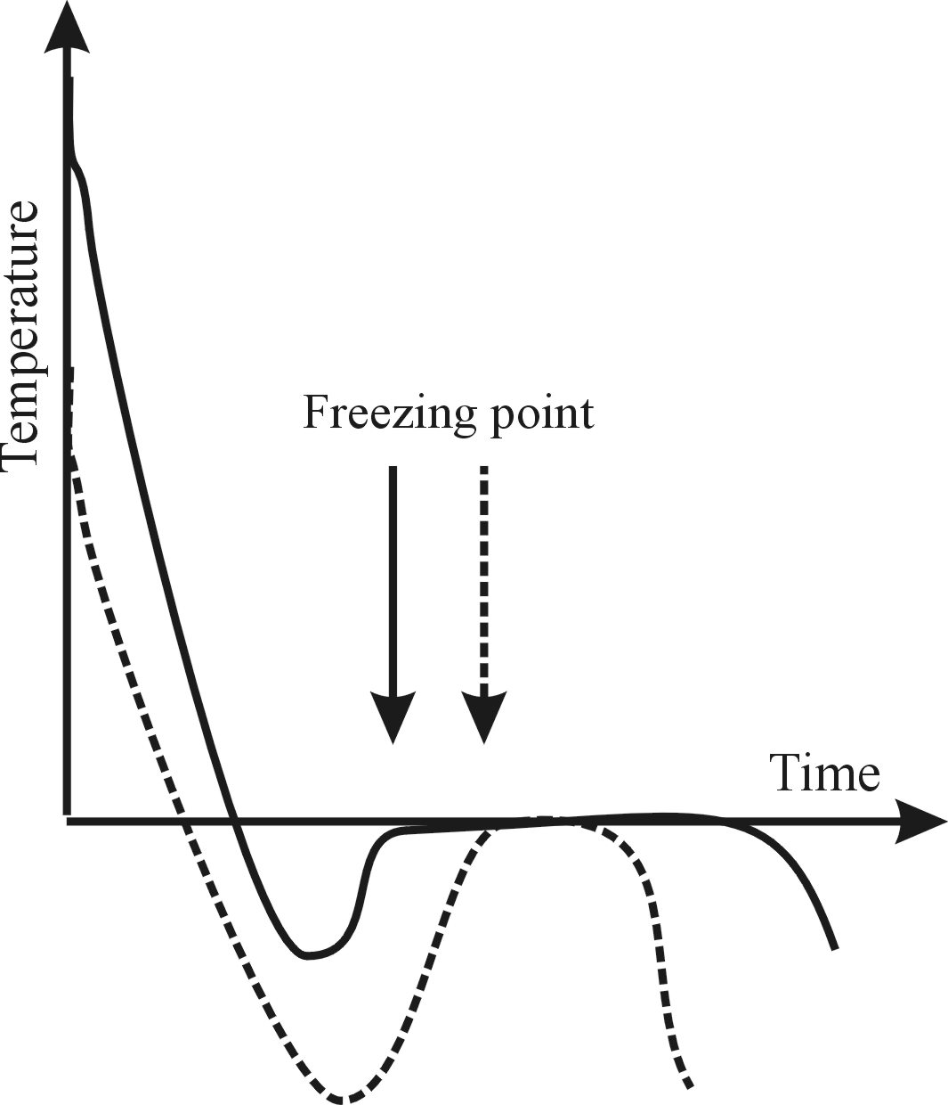

Fig.4. The initially-hot water appears to freeze earlier (solid line) as initially-cold water (dashed line). This doesn't mean that initially hot water would freeze completely first.

There have been many attempts to explain the Mpemba effect, but probably the most likely scenario is based on effect of supercooling. Note, supercooling occurs when the water freezes not at 0°C, but at some lower temperature. The explanation is that cold water has high concentration of icosahedral cluster. On the other hand, initially hot water has lost much of its ordered clustering and, if the cooling time is sufficiently short, the cluster will not re-attained before freezing. It has been shown that clustering process may take some time. Liquid – ice phase transition needs rearranging of water molecules from some initial (liquid) state to hexagonal structure which is typical for ice under room conditions. If in liquid water exist icosahedral clusters these should be destroyed before forming the hexagonal structure. This process needs some time and may invoke that cold water starts freeze later than hot water. However, this doesn't necessarily mean that initially hot water would freeze completely first.

Numerical simulation of water properties
In general, computer simulations are able to reproduce many of the transformations between ice, amorphous ice, and liquid water observed in experiments. This is surprising because there are based on the different accessible scales: experiments are limited by the largest accessible compression and cooling rates, ranging up to ∼6000 MPa min⁻¹ and about 100 K s⁻¹, while computer simulations are limited by the slowest accessible rates of about 1000 MPa min⁻¹ and 1000 K s⁻¹. This difference in scales implies, that some phenomena observed in experiments cannot be reproduced in simulations (for example, liquid water crystallization is extremely difficult to observe in simulations, even at the slowest accessible cooling rates).

Before we start any numerical experiment we have to have good model. Many 'hypothetical' models for water have been developed in order to discover the structure of water. The idea is if the model (that is, computer water) can successfully predict the physical properties of liquid water then the (unknown) structure of liquid water could be determined. However, the agreement among many results obtained from computer simulations and experiments are still in question. The possibility of simulating processes difficult to perform in experiments, has resulted in a synergism between experimental and computer simulation groups.

Conclusion
In this review I have discussed some properties of water. It has been shown that water is most atypical as a liquid or solid, behaving as a quite different properties at low temperatures to that when it is hot. Notable amongst the anomalies of water are the opposite properties of hot and cold water, with the anomalous behavior more accentuated at low temperatures where the properties of supercooled water often diverge from those of hexagonal (normal) ice. The number of anomalies that we know is sixty three. Most of then are full explained, but some details are still obscure and will be explained (hopefully) in near future. Before the concluding I should repeat that water is very miracle liquid. It has been recognized throughout history by civilizations and religions and is still the case with scientists today that life required water (at least at the Earth). The main conclusion of this paper is that water is worth to be protected and studied.

References
Martin Chaplin: http://www.lsbu.ac.uk/water/

