Atomic Force Microscope System: Dimension Edge (Bruker AXS Inc., USA)

Software: NanoScope Analysis 1.2 (Veeco Instruments Inc., USA)

Imaging Mode: Tapping

Sample: Polished Fe_{94.769}C_{0.18}Si_{0.24}Mn_{0.52}Mo_{0.62}Ni_{1.26}Cr_{2.22}Cu_{0.080}P_{0.010}S_{0.013}V_{0.08}Co_{0.008} steel

Description: Surface of the sample was etched by HCl acid. The acid was mixed with water in ratio of 1:15 and applied in two steps. The sample was first immersed in acid for 2 minutes and then checked on optical microscope. After that, it was immersed again into the acid for the time of 5 more minutes.

AFM/MFM Image Description

Vert. distance | Pixel no. | Line no.
0 | 0 | 1
… | … | … |  | Image
n [µm] | 511 | 512
 |  |  |  | Horiz. distance
 |  |  | 0 | … | n [µm]

Colour bar:
AFM – height [nm]
MFM – phase shift [°]
Scan 5: 1 × 1 µm²

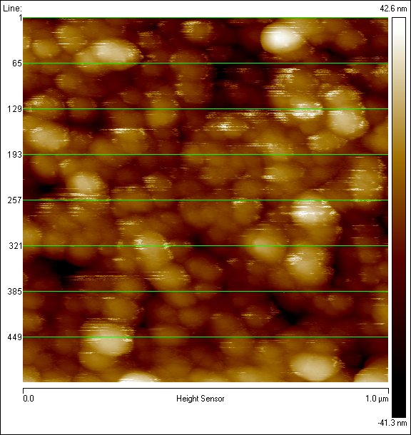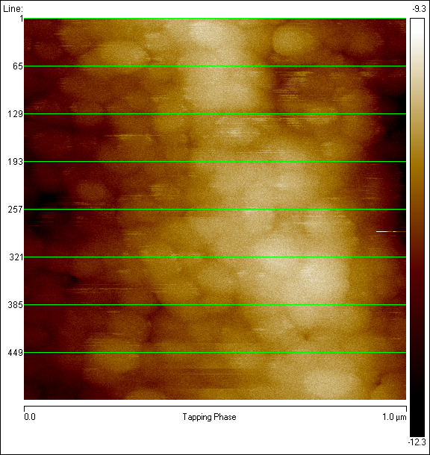
Topography Magnetism

Topography Magnetism
(y-axis: normalized height) (y-axis: normalized phase shift)

Scan 6: 3 × 3 µm²

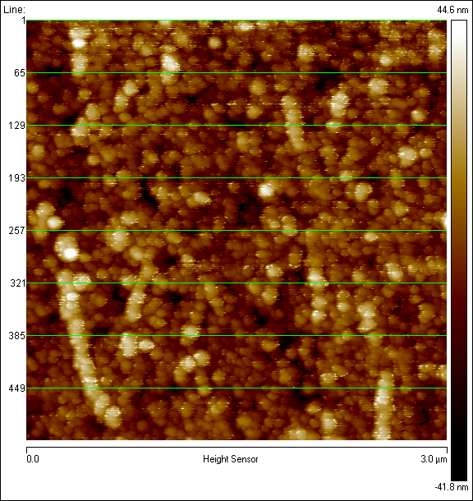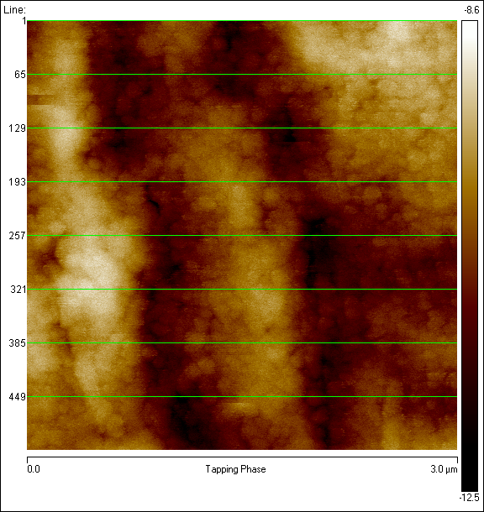
Topography Magnetism

Topography Magnetism
(y-axis: normalized height) (y-axis: normalized phase shift)

Scan 7: 20 × 20 µm²

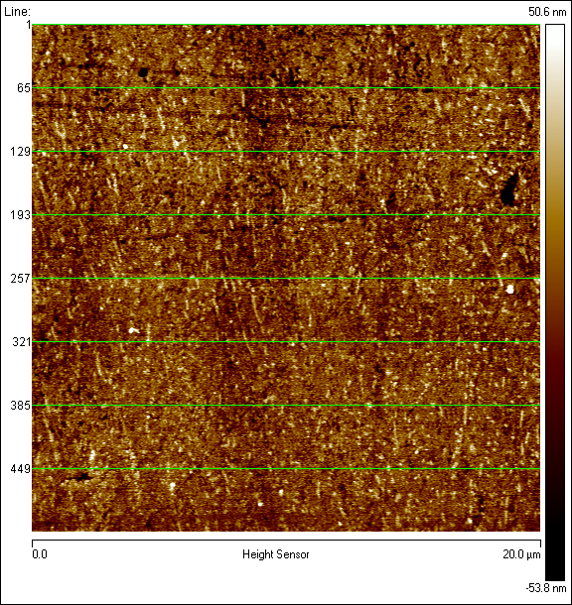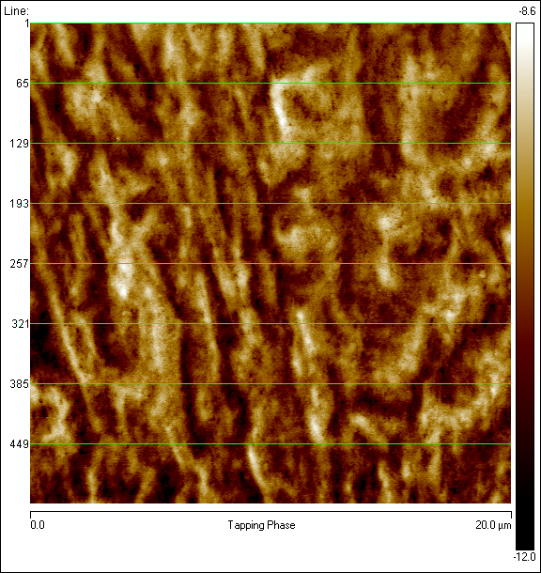
Topography Magnetism

Topography Magnetism
(y-axis: normalized height) (y-axis: normalized phase shift)

Scan 8: 20 × 20 µm²

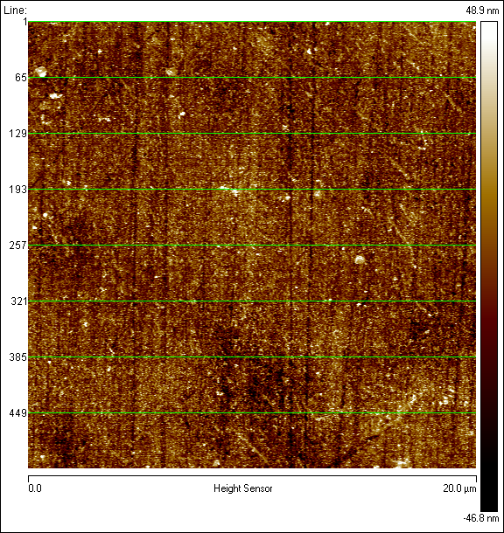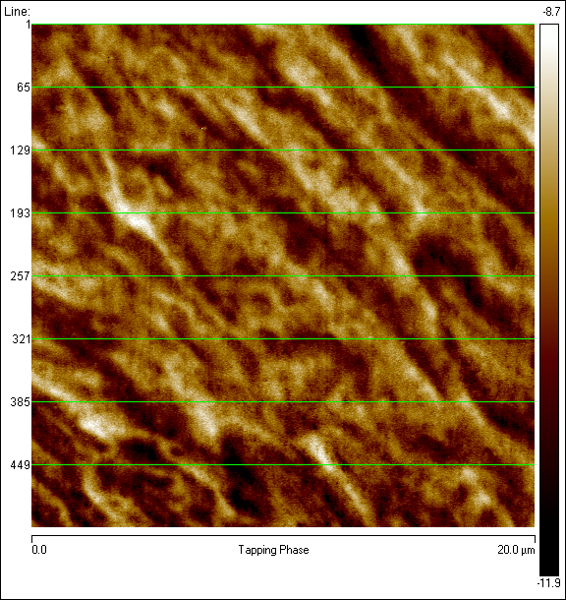
Topography Magnetism

Topography Magnetism
(y-axis: normalized height) (y-axis: normalized phase shift)

